University of london  CM2020

ASP8 Tower defence documentation

ASP8 Team members:

* Alex Chu
* Dimitri Vlachos
* Freda Xiaoyun Yu
* Jeremy Matthews

Github route for codes: <https://github.com/matthewsja/asp8_TowerDefense>

Github route for files: <https://github.com/FredaXYu/ASP_Group8>

Link for out game: <https://aspgrp8.z1.web.core.windows.net/>

Link for final report: <https://github.com/FredaXYu/ASP_Group8/tree/main/after_midterm/finalterm_proposal>

---------------------------------------------------------------------------------------------

Table of Contents

audioManager 2

audioManager.mjs 2

Map Objects 3

enemy.js 3

Play Objects 3

enemy.js 3

gameStats.js 3

hud.js 4

hudLogic.js 5

hudLogicTower.js 6

map.js 6

mapLogic.js 7

mapLogicEnemy.js 8

mapLogicTower.js 9

states 10

bootstrap.js 10

complete.js 11

level.js 11

menu.js 12

over.js 12

play.js 13

treasure.js 13

utilities 133

checkJSON.js 13

gameRecords.js 14

resources.js 14

# audioManager

## audioManager.mjs

The audio manager is used to manage the audio of the game. The music, SFX and so on.

### Parameters

* _soundManager Phaser’s default soundManager for the audioManager to manage.
* _sfxEvents A list of sfx ‘events’ to be called by the playEffect() function.
* _musicEvents A list of music ‘events’ to be called by the playMusic() function.
* _musicSounds A list of music ‘sounds’ to be called by the playMusic() function and looped.
* _volume (default: 1) The audible volume of all sounds.
* _musicVolume (default: 1) The audible volume of all music.
* _sfxVolume (default: 1) The audible volume of all sfx.
* _currentMusic (default: undefined) Music to be playing currently.

### Functions

#### pause()

Pauses all sounds being played by the audioManager.

#### resume()

Resumes all sounds being played by the audioManager.

#### stopAll()

Stops all sounds being played by the audioManager.

#### playMusic(musicEvent)

Plays the musicEvent, adding it to the list _musicEvents if it is not already in it.

#### stopMusic()

Stops music from playing.

#### playEffect(sfxEvent)

Plays the sfxEvent, adding it to the list _sfxEvents if it is not already in it.

#### getVolume()

Returns the value of _volume.

#### setVolume(volume)

Sets the value of _volume.

#### getMusicVolume()

Returns the value of _musicVolume.

#### setMusicVolume(musicVolume)

Sets the value of _musicVolume.

#### getSfxVolume()

Returns the value of _sfxVolume.

#### setSfxVolume(sfxVolume)

Returns the value of _sfxVolume.

#### _getInstance()

Returns the _instance. Unless no instance exists, in which case it returns null.

# Map Objects

## enemy.js

This class extends the Phaser class Phaser.GameObjects.PathFollower, since enemies need to follow a settled path.

Functions

constructor (config)

Sets configurations for the enemy.

follow(self)

Let enemies follow the specified path.

destroyEnemy(self)

Remove the enemy when its Hit-Point is 0.

# Play Objects

## enemy.js

Same as mentioned above.

**Below files**, each is a class extended from Phaser.Scene, and each is set a keyword in the constructor with the format: 

## gameStats.js

It handles game statistics.

**Create()** method documentation: <https://newdocs.phaser.io/docs/3.55.2/Phaser.Types.Scenes.SceneCreateCallback>

Within it, firstly reuse data from other scenes:

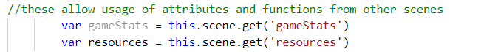

Then import map data from resources scene:

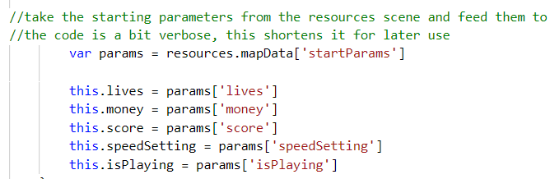

**Update()** method documentatation: <https://newdocs.phaser.io/docs/3.55.2/Phaser.Scene#update>

Within it, use attributes and functions from other scenes:

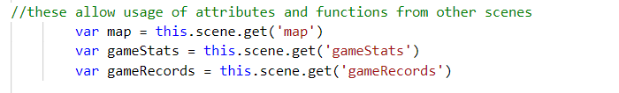

Set the game over state when lives go to 0.

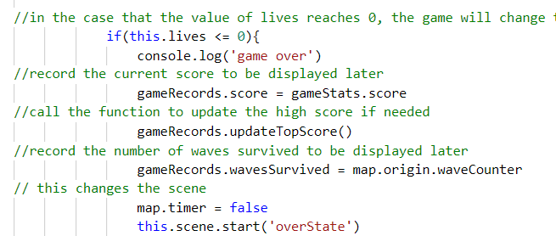

Set speed:

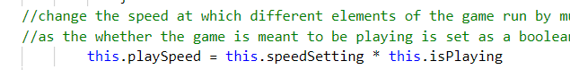

## hud.js

Describes functionalities in the User Interface when playing the game where the map displays.

Load data from other scenes:

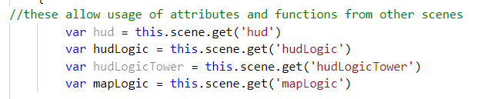

Import the tile logic which is how the map is built and is written in another file later:

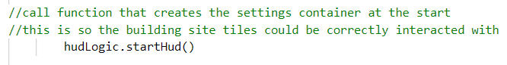

Add the menu button at top right:

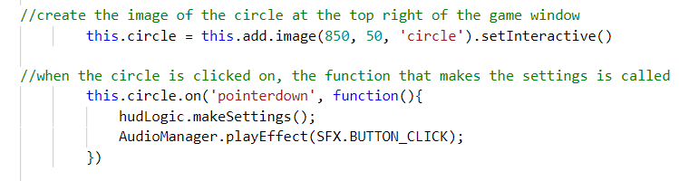

Add the speed-changing button at the bottom:

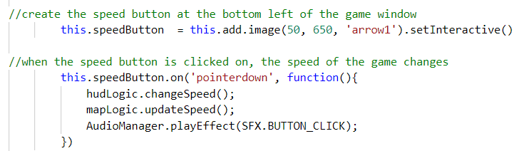

Within **update()** method, after loading data from other files, (1) add buy-tower functionality; (2) update different game statistics; (3) let the timer runs normally:

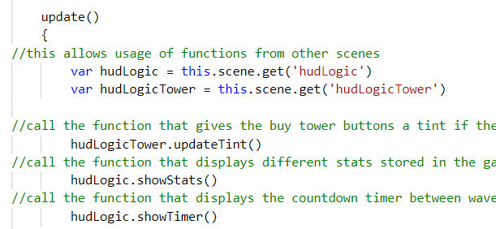

## hudLogic.js

Manipulates the logic of HUD elements.

Set menu with 3 buttons, save the current map to be resumed:

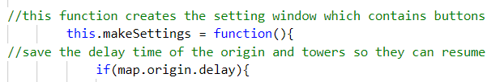



Then draw buttons and set interactions with specific outcomes. This step is difficult since it requires programmers to think about all the elements in each state comprehensively.

Then draw the speed-changing button and set options:

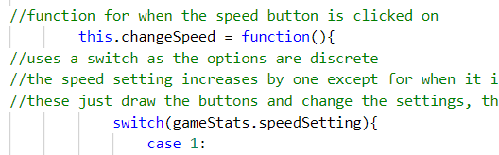

Then show the game stats:

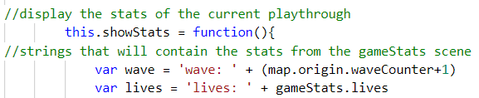

And show the timer:

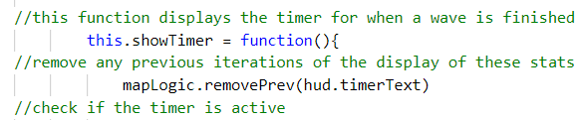

## hudLogicTower.js

Mainly manipulates the towers shown in the HUD, i.e. buy tower, sell tower, tower upgrades, etc.

After reusing data from other files,

#### this.makeTowerMenu = function(tile)

Function that creates the tower menu. Takes in as a parameter the tile that was clicked on which caused the function to be called.

#### this.makeMenuBuy = function(tile)

Function that displays all the towers that could be bought. Takes in the tile the that was clicked on.

#### this.updateTint = function()

Function that would dim the buy button in the tower menu if the cost of the tower exceeds the amount of money at the moment. The button reverts back to normal when there is enough money.

#### this.clickBuy = function(button, tile, tower)

Function that allows the buy buttons in the tower menu to be interacted with interactions involve hovering the mouse over is and clicking it to buy the tower. Takes in as parameters 1)the button in question, 2)the tile the tower menu is for and 3)the tower the button is for.

#### this.makeMenuStats = function(tile)

#### Shows the stats of the tower in the building site that was clicked on. Takes as a parameter the tile that was clicked on.

#### this.removeTower = function(tile)

Removes a tower from building site. Parameter: the tile the tower is to be removed from.

## map.js

Mainly summarises all of the interactions and logics done by other files.

Set all the towers, enemies, and bullets into groups:

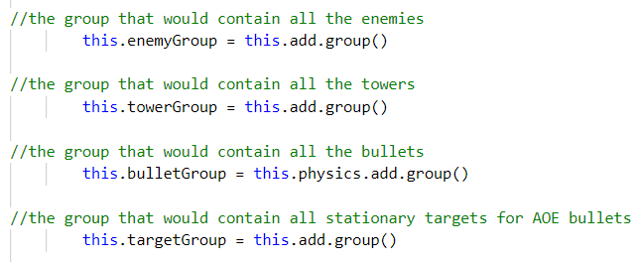

Then import tile logic. Set enemies’ path.

Then add the ‘start’ button and set interactions.

In **update()** method:

Update (1) speed changes; (2) remove bullets; (3) determine the attack speed of towers; (4) searches for any enemies that are in a tower's range; (5) checks the state of the origin and creates an enemy if the state is the right one; (6) determine how fast the enemies spawn in a wave; (7) handles the countdown between waves; (8) call the next next wave when the rush button is clicked; (9) when a building site tile is clicked on, it opens up the tower menu in the HUD.

## mapLogic.js

Contains the functions and methods that are generally called by map.js.

extends from Phaser.Scene. Contains the functions and methods that are generally called by map.js.

After loading attributes and functions from other scenes, draw the map and set up the interactivity within it:

#### this.drawTiles = function(tileCoords, tileset, size)

Function for drawing the tileset to the map. Takes in as parameters 1)the array of indices indicating what tile goes where, 2)the tileset image and 3)the size of the tiles.

#### this.makePath = function(tiles, origin, destination, pathTiles, size)

Function for making the path which the enemies will travel on. Takes in as parameters 1)the array of indices showing what tiles are where, 2)the indices of the origin and 3)destination, 4)the array of indices indicating what tiles the enemies could travel on and 5)the size of the tiles in pixels.

Then find the coordinates in tiles units the origin and destination tiles.

Create a zone object which will have many parameters controlling the spawning process.

Create a physics image object which when enemies go over, a life is lost and the enemy is removed.

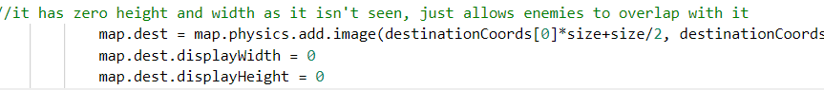

To find the path, the external library easystarjs is used to do an A* search.

#### this.findTile = function(tiles, type)

Function used to find a specific tile in a tile array. Takes in as parameters 1)the array of indices indicating where different tiles go and 2)the index of the tile to find.

**General functions:**

#### this.updateSpeed = function()

Function for changing the movement speed of the current enemies and bullets as well as the reload speed of waves and towers and the cooldown time of of the origin during play. Within it: update the movement speed of bullets; the movement speed of enemies; the cooldown speed of the origin; the reload speed of the wave; the reload speed of the towers. Then add a ‘start’ button to let enemies in.

#### this.removePrev = function(object)

Function for removing the previous version of an object so there won't be multiple versions of the same object. Takes in as a parameter the object to attempt to remove.

## mapLogicEnemy.js

Contains the functions and methods that are generally called by map.js relating to the enemy objects.

### Functions

#### this.makeEnemy = function(key)

Function that makes the enemy object. Takes in as a parameter the key of enemy to make.

If the origin is ready to make another enemy: create a new enemy object; give it attributes for when it is moving and being attacked and its size; set how far the enemy has to travel; set its speed; set the HP bar (loads of codes); make the enemy follow the specific path at a specific speed; check if enemy reaches destination.

#### this.removeEnemy = function(enemy)

Function for removing the enemy. Parameter: the enemy to remove.

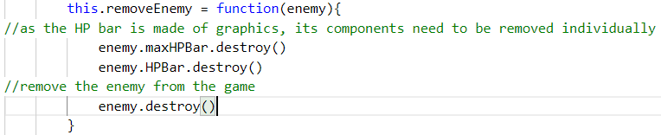

#### this.debugEnemy = function(enemy)

Function for removing an enemy in case it is buggy. Parameter: the enemy to remove.

#### this.updateHPBar = function(enemy)

Function for updating the HP bar of an enemy. Parameter: the enemy whose HP bar to update.

#### this.startGame = function()

Function for starting the game proper by sending the first wave.

#### this.rushWave = function()

Function for starting the next wave prematurely when the rush button is clicked on while the countdown is active.

#### this.makeWave = function(waveData)

Function for changing the parameters of the origin so it is ready for another wave. Parameter: the data for the next wave.

#### this.updateWave = function()

Function for determining the speed at which the enemies are made. Also stops making enemies when enough have been made.

#### this.reloadWave = function()

Function for changing the state of the origin so more enemies could be made.

#### this.coolDown = function()

Function for seeing if the origin is ready for another wave and if it is, call a function to change the origin parameters to fit this state. Also determines if the winning conditions have been met in which case the game state will change to the game complete state.

#### this.callNextWave = function()

Function for calling the next wave.

#### this.enemyReachDest = function(enemy, dest)

Function for when an enemy reaches the destination. Parameters: 1)enemy; 2)destination.

## mapLogicTower.js

Contains the functions and methods that are generally called by map.js relating to the tower objects.

### Functions

#### this.clickSite = function()

Function for when a building site tile is clicked on.

#### this.makeTower = function(tile, key, size)

Used to create a tower at a specific point. Parameters: 1)the tile to make the tower in, 2)the key of the tower and 3)the size of the tiles.

#### this.clickTower = function(tower)

Function for when the tower is clicked on. Parameter: the tower that was clicked on.

#### this.searchEnemy = function(enemy)

Function for searching for an enemy within a tower's range. Parameter: the enemy being searched.

#### this.enemyFound = function(enemy, tower)

Function for when an enemy has been found. Parameters: 1)the enemy that was found and 2)the tower that found it.

#### this.makeBullet = function(enemy, tower)

Making the bullet. Takes in as parameters 1)the enemy being targeted and 2)the tower that the bullet originated from.

#### this.updateTower = function(tower)

Regulating the attack speed of the tower. Takes in as a parameter the tower being affected.

#### this.reloadTower = function(tower)

Changing the state attribute of a tower so it may fire another bullet. Parameter: the tower being affected.

#### this.moveBullet = function(bullet)

Moving the bullet. Takes in as a parameter, the bullet that is affected.

#### this.hitTarget = function(bullet, target)

Function for when the bullet reaches its target. Parameters: 1)the bullet and 2)the target.

#### this.damageEnemy = function(bullet, enemy)

Responsible for damaging the enemy. Parameters: 1)the bullet that will damage the enemy and 2)enemy itself.

#### this.updateBullet = function(bullet)

Function for when a target enemy is destroyed before a targeting bullet has made contact with it. Takes in as a parameter the affected bullet.

# states

Each file is one class which is extended from Phaser.Scene, and each is set a keyword in the constructor with the format: 

## bootstrap.js

Handles what happens when the winning conditions for the game are met. This file loads and initialises all of the Phaser objects for the audio manager in order to facilitate testing as the mocha.js testing suite crashes when it tried to load Phasers objects, meaning we had to remove this section from that code in order to run our tests.

First we import Phaser and the audioManager itself: 

Then we launch all of our scenes necessary to run the game:

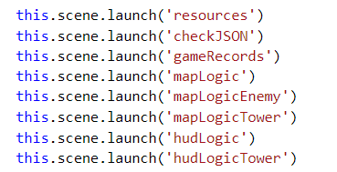

Then we create our scene loader/switcher, allowing us to change between scenes:

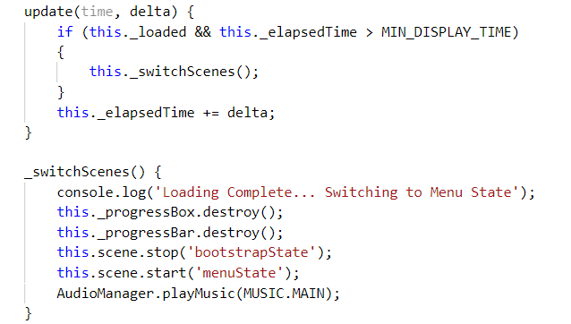

## complete.js

Handles what happens when the winning conditions for the game are met.

First we stop the other scenes to prevent them from overlaying this one:

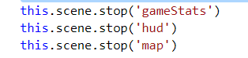

Load the gameRecords: 

Create new variables and show them:

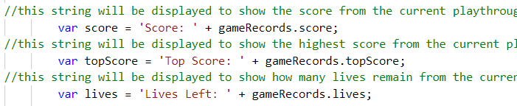

Add logic to trigger the ‘happy ending’ page if the condition is ‘instant win’.

Display: 

Create 3 buttons: ‘menu’, ‘level’, ‘restart’.

## level.js

This is the level selection scene for selecting levels.

We close other scenes to prevent them from overlaying the menu:

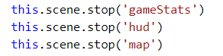

Add a title bar:



Create the ‘back’ button at top left:

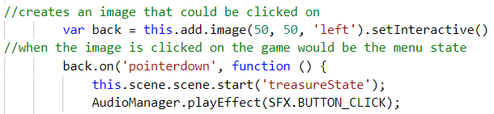

Then add the functionality:

#### this.levelButtons = function()

This function positions the buttons which when clicked on would take the player to the level that was clicked on. Create a for loop to build level buttons.

#### this.makeButton = function(level, x, y)

This function is used to make a button for each level that could be played. Takes in as parameters 1)the key of the level and the 2)x and 3)y coordinates of where the button would be located.

#### this.clickButton = function(level)

Function to handle what happens when a level button is clicked on. Takes in as a parameter the name of the level.

Call the functions.

## menu.js

Handles the main menu of the game.

First we stop other game scenes.

Add background image:



Then we create the ‘start’ button at bottom, and set interactions and sounds:

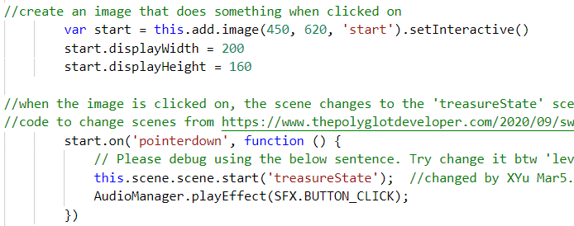

## over.js

Handles what happens when the defeat conditions for the game are met.

After stopping other scenes, we display the results of the game:

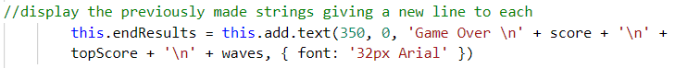

We then display 3 buttons:

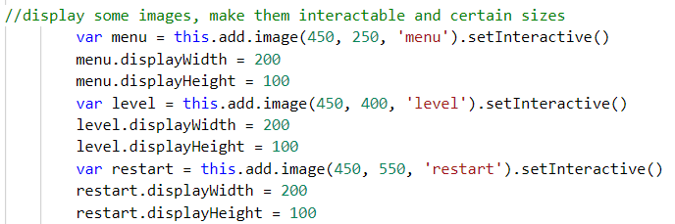

And set interactions and sounds.

## play.js

Handles what happens when the game is being played.

Start all the scenes that make the game up itself:

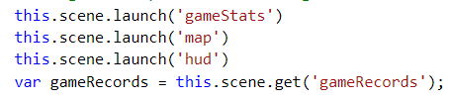

Make sure ‘instant win’= False, since users haven’t set ‘the Law’ yet:



## treasure.js

This is the ‘treasure box’ page which shows lists of characters.

Firstly, stop interactions from other pages:

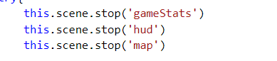

Then, add the background picture from the resource.js:



Create a ‘start’ button and set interactions.

# utilities

## checkJSON.js

This utility extends Phaser.io’s default Phaser.Scene. It allows for the application to validate JSON files, ensuring their integrity and compatibility with the application.

### Functions

#### checkDict(dict, keys)

Checks that every relevant value of a given dictionary is the right data type.

It takes, as input:

* dict, the dictionary to check.
* keys, a second dictionary that contains the data types for all of the relevant values for any dictionary used in the game. Only those covered by the key dictionary are checked.

#### checkLevel(dict, data, key)

This function is used specifically for checking the inner arrays of the level dictionaries.

It takes, as input:

* dict, the dictionary to add the data to.
* data, the dictionary containing all of the data to check.
* key, the key of the dictionary to check.

By default, all dictionaries pass, therefore, the data may be added to the larger level dictionary. If any of the tests fail, then it will not be added to the larger level dictionary.

## gameRecords.js

This utility extends Phaser.io’s default Phaser.Scene. It allows for levels to be selected

### Parameters

* levelSelect (default: -1) This is how the levels are selected and the selection is preserved.
* wavesSurvived This records how many waves the player has survived.
* lives This records how many lives the player has remaining.
* score This records the highest score the player has attained during the current game session.
* topScore (default: 0) This records the highest score the player has attained during the current game session.
* instantWin (default: false)

### Functions

#### updateTopScore()

Updates the top score by comparing it to the current score. If the current score is higher, then the top score is changed to the value of the current score.

## resources.js

This utility pre-loads all of the necessary assets for the game.